Christian Assembly Newsletter August 2018

关于基督徒婚姻的分享

-秦汉弟兄和Sis. Faith

“我如何知道神的旨意如何呢?”
这是许多年轻人最常问的问题之一, 有时是关于学习哪个专业，有时是关于从事什么职业，但更多时候是关于：“我如何知道谁是神为我预备的人？”
神希望我进入婚姻还是保持单身？神会为我预备合适的人吗？我能知道神的心意吗？当我们查考圣经，我们会很疑惑，因为有很多故事记载了人们如何遇见他们的配偶：亚当和夏娃；以撒和利百加；雅歌和拉结；甚至何西阿和歌篾。在这些故事里没有相似性可以让我们借鉴，帮助我们做决定。甚至我们发现教会中有各种不同的故事，没有相同的故事。
当我带着虔诚的心回到神面前, 我更加明白神的心意并不是我是否该结婚或是和谁结婚, 而是我们在地上的日子是一个炼净我们的过程，这个过程是我们可以成为神期望中的新妇。
在这个过程当中会有眼泪和心碎，也有喜乐。但是要记得，神看重我们的圣洁，胜过看重我们的幸福， 因此，即使是我们在婚姻的这一领域很难知道上帝的意愿，这也是我们与他的关系越来越紧密的一部分。
你现在在为这些问题困惑吗？与你亲密的弟兄或姐妹一起向神祷告吧！慢慢地，生灵会带领我们进入放下属世的情欲进入对神更深的降服，我们会发现我们已经有一位完美的丈夫，我们正在预备自己进入更伟大，更美好的婚姻。

Summary of what the youths learnt at CF

-Sharing by Bro. Nigel on behalf of the youth

We started off listing out our favourite wedding verse. Least to say, there were many many verses quoted. From those that were married, things like getting the shortest verse to fit in the wedding invitation was important. But why do we want to be married? And must we?
What is our life partner supposed to be like?
Whether we admit it or not, we all have list of what our future partner is to be like. But is this what God calls for you?
We learnt how important it is to put God first in everything, to make Him the one who guides our life. Be it getting married or not, God doesn't call for one choice or the other, but instead submission to Him who knows best for you.
This isn't just praying about the person you feel attracted to. But giving up all your entire list of criteria, and to see the person in God's perspective, a person who will choose God over anything, even you, and a relationship where you can both build each other up spiritually.

所以…..婚姻是什么???

Bro. Keen Mun & Sis. Janet- “婚姻是神所设立的，二人成为一体，成为基督与教会关系的见证。也就是说作为一体，我们应该同心合意地敬拜神，完成他的旨意。比如，家庭中，教会服事中”。

Bro. Chun Huat & Sis. Karen- “结婚时我们还不是信徒，那时的挑战和心碎是我们经历的让我们不得不承认我们被击败了。感谢神的恩典，他通过Karen的疾病把我们找回，因为这场疾病，我们在结婚四年后信主了。我们被那句“你不知道的东西不会伤害你”的观点欺骗了。我们决定对彼此坦白我们的过往，但是这并不是没有痛苦的。我们很挣扎，但是神柔软了我们的心，我们原谅了彼此。神为了他的圣洁设立了婚姻。所以，婚姻中的双方都必须是他的孩子才能接受他完全的祝福。愿我们都对我们的配偶毫无保留，这样那恶者就不能控告我们。
May we also purpose to keep nothing from our spouses to prevent the fiery darts of accusation from the evil one.”
Bro Hock Heng & Sis Bee Hong- “婚姻是三方的约的关系：神，男人和他的配偶（女人）。这段关系不是匆忙毫无考虑地进入地（创世纪2：18，21-23）。”
Bro. Lim Yong & Sis. Jenny- “在我们参加过的许多婚礼上，婚礼主持者提到了耶稣所行的第一个神迹，在迦拿婚宴上他使水变成了酒。下面是我们谦卑的思想：
婚礼的叙述——从伊甸园开始到基督的“婚姻圆满”，新郎归来迎娶他的新娘，教会——是圣经中一个突出的主题。所以， 我们应该承认并维护婚姻的神圣性。“

选择生活伴侣，
要考虑哪些因素?

Bro. Lim Yong & Sis. Jenny
当选择伴侣时，有三个重要的因素应该被考虑：
- 这个人是在基督里地吗? （哥林多前书 6:14）
- 你选择的是神选择的吗? (马太福音 6:33-专心寻求他的国和他的义，遵行他的旨意，然后我们所需要的，比如婚姻，会按照他的时间成就)
- 只有在听到神的声音后才开始行动 – 不是我们自己的内心的声音（创世纪12:4a – 照着耶和华的吩咐去）。
Bro. Sagar & Sis. Elizabeth
1. 从圣经中我们知道，婚姻是荣耀的- 所以第一个考虑因素是夫妻双方都应该愿意尊重和荣耀神（我们的主耶稣基督）。
2. 只与真正重生得救，受洗归入基督的人结婚。
3. 对神的旨意有合适的、充分的保证和确认。
4. 未婚者不应该与离婚的人结婚。
5. Look for spiritual Christ like qualities and Worth rather than physical.
6. 夫妻双方都应该对神的家有同样的属灵的负担和意象。比如：教会，团契，宣教。
7. 与其他教派的人结婚会引起家庭的混乱，尤其会使孩子困惑。
8. 婚姻不像这个世界所定义的仅仅是两个人身体上的结合。婚姻是天上的父一个神圣的设计，这个设计是为那些全心信靠他并且相信他的话——圣经的人预备的。
9. 父母应该参与进来，并且在祷告当中给予合适的引导
Parents should be involved and proper guidance in prayer from the Spiritual servants and Men.
Bro. Chris & Sis. Ivy
在我看来，选择配偶并不是寻找一个人进入婚姻， 而是预备好我们自己，能够与神为我们预备的人进入婚姻。我记得我大约10-12岁时向神祷告，求神保守我的纯洁和贞洁，好使我能成为我未来丈夫的好的帮助者。除此之外，我也求神，让我在单身期间能全心地寻求他，服侍他。与此相似的时，Chris 为他的婚姻祷告时,神用这节经文鼓励他“神造万物，各按其时成为美好，又将永生安置在世人心里。然而神从始至终的作为，人不能参透。”传道书 ‭3:11‬ ‭NKJV‬‬, 是我们婚礼上的经文。我们是如此不同的个体，我们的脾气不同，性格不同，特性也不同。只有神能让我们的不同都如此的美丽。

Bro Hock Heng & Sis Bee Hong
首先，双方之间能互相吸引：他们必须喜欢彼此的陪伴，并有一些共同的兴趣，愿意做出一生的承诺。
你的配偶必须是一个重生的基督徒，如果你们同样渴慕寻求神，对神存同样的心思，那就更好了。（阿摩司书 3:3, 哥林多后书6:14）。
其次要考虑他/她的性格，行为和习惯，对于这些你可以欣赏并能够接受。在这个问题上，你可以通过在不同的情况下观察你未来的配偶，看看他/她是如何表现或行动的；看看他/她是如何与家人、朋友还有其他人相处的，这会帮助你更好的了解她/他的品性。
双方的受教育程度和社会地位不应该有太大的差距：因为结婚以后，你需要陪伴你的配偶出席一些场合，见一些亲戚，融入对方的交际圈，不同的教育程度和社会地位会对这些有一定的影响。
除此之外，还应当考虑供养家庭的经济能力，双方追求的生活方式。
但是最重要的是寻求神在这个重大决定上的引导 （以赛亚书58:11）。

Now, we turn to couples who have been married for some time to share with us important lessons from their marriage…

Bro Hock Heng & Sis Bee Hong
Willing to accept the need to leave your own family and establish a new home with your spouse. This mean not only to live physically apart but also allow for independent living free from the influence of the parents (Gen.2:24).
Of course, this does not mean to sever ties with your families; and any assistance is welcome. This avoid over reliance on parents and allow for the marriage to flourish and grow as you face life challenges together.
The marriage vows remind us the relationship is bound by steadfast love, faithfulness and a commitment that only death put apart.
This require constant effort, making choices, sacrifices and adjustment to accommodate one another in various stages of life. (Example: when the children come along or when one party become sick.)
Each party must be responsible and must pay mutual respect; providing comfort and hope to their partner.
Disagreements, even quarrels are inevitable and need to be manage with love and consideration for the other person. As we value our spouse more than ourselves, our marriage will grow as we build up one another in love. As we experience the unconditional love of Jesus Christ, we can love our spouse as He loves us (Eph.52,22-29).

Bro. Chris & Sis. Ivy
We do have disagreements. As God is the centre in our marriage, He binds us closely.
“.... And a threefold cord is not quickly broken.”
‭‭Ecclesiastes‬ ‭4:12‬b NKJV‬‬
It’s important to have couple time no matter how one is busy at work or minding the children. I really agree with what Sister Linda shared in Church Camp 2017. In our initial stage of our marriage, I used to think I loved Chris more, and felt neglected as he was busy at work. Now, as I begin to be more independent, being busy with children and others, it seems like Chris loves me more. We appreciate each other more as the years of marriage roll on. Now he laughs at every wry comment I make, which he didn’t understand in the past. And we laugh and tease each other very often. I also complement him in areas he is weak at. Indeed, we hope to echo with these verses from Song of Solomon
“I am my beloved’s, And his desire is toward me.”
‭‭Song of Solomon‬ ‭7:10‬ ‭NKJV‬‬
“My beloved is mine, and I am his. He feeds his flock among the lilies.”
‭‭Song of Solomon‬ ‭2:16‬ ‭NKJV‬‬
Solomon’s love toward his Shulamite lover is deep, so is hers to her beloved.
Bro. Lim Yong & Sis. Jenny
Important lessons we are (still) learning in the Lord in order for our marriage to work:
- Being aware of your role in the marriage: husband as head of household, to love the wife. Wife to submit to husband as head (Ephesians 5:21-33; 1 Peter 3:1&7)
- Put aside your pride, prejudice and presumptions. Be ever ready and willing to lend a listening ear. Be a "helper" to your spouse (Genesis 2:18) - be open when sharing your problems and fears
- Be sensible and sensitive to the other party's physical and emotional needs (1 Corinthians 7:3-5)
- Form a close support group with like-minded brothers- and sisters-in-Christ to find and lend support in times of spiritual and physical needs (Proverbs 17:17)
- Devote time to pray together (which admittedly we fail to do much)(Philippians 4:6; 1 Thessalonians 5:17; James 5:16)
Bro. Keen Mun & Sis. Janet:
To know that it is God, by His grace, who has brought us together to make us complete in Him, and I remembered what our late brother Timothy Sun said "what God provided is the BEST for me". Since it is God who has made everything beautiful in His time, we need God always to make our marriage works; otherwise, we will not be able to manage the challenges in parenting, crisis/ trials in our life and ups and downs in husband-wife relationship, etc.
Because as ONE, we need to be ONE in spirit, mind, heart in our relationship, it is important to have communications and fellowship with one another so as to be like-minded in God's ministry and service. However, this is one area still works in progress, and much to learn. Another thing is to love God and to walk close to God. Only then can we love one another in the love of God.


Notes and News

Erratum in the Notes and News section of July’s issue of Newsletter
Brother Clement Chong and Sis Ka Woon’s wedding was on “30 June 18” instead of “30 July 18”. The editorial team apologizes for the typographical error.

Thanksgiving
We thank God that He has seen Sis Ling Kam through the operation to remove cancerous tissues from her right breast. Please continue to pray for her speedy & complete recovery as she recuperates at home.

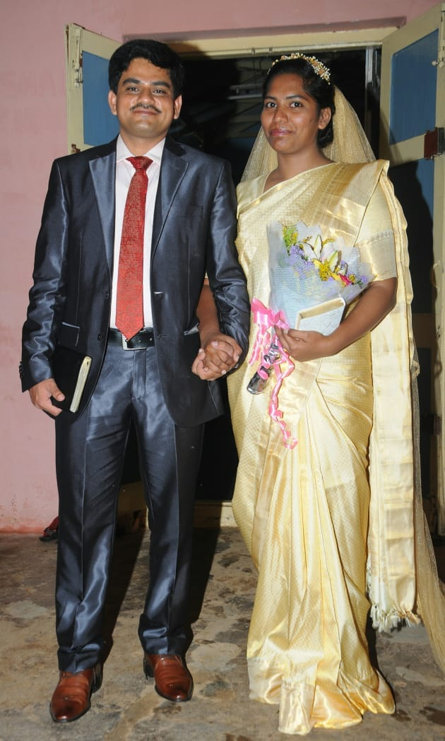
Wedding bells
We rejoice with Bro. Anil and Sis. Rachel on their Holy Matrimony on 26th May 2018 in Bengaluru, India.

May the Lord bless the newly wedded couple in their lives ahead!

Baptism Service – 19 Aug 18
Many in our assembly have believed in the Lord but have yet to take this step of obedience. Pray for the Holy Spirit’s conviction, removal of doubts/fears, desire to give God glory and boldness to declare their identity in Christ.
Gospel Service
Gospel Service every 1st week of the month - Pray that we be active in inviting family & friends to hear the good news and to participate in the great commission.


Be careful for nothing; but in everything by prayer and supplication with thanksgiving let your requests be made known unto God. (Philippians 4:6)
And the peace of God, which passeth all understanding, shall keep your hearts and minds through Christ Jesus. (Philippians 4:7)

Prayer items
Watch and Pray

Pulpit ministry
- God’s anointing on the speakers
- God’s word to be faithfully discharged & HS to work mightily to transform the hearts of the listeners.
- All to have attentive ears, willing hearts, a submissive spirit to hear what God is saying and to obey.
Speakers for the coming weeks are:

Date | Speakers
Date | Wilkie | Asiawide | Gospel
05 Aug 2018 | Eddy Lim | Yeo Choon Guan | Eddy Lim
12 Aug 2018 | Chan Keen Mun | Pat Mun Fai
19 Aug 2018 | Chng Yak Beng (Combined Baptism Service)
26 Aug 2018 | Sng Hock Heng | Teo Ching Han

Sunday School
- Sunday School teachers to fully depend on God to teach & be true to God’s Word.
- Sunday School students to come early with the desire to study God’s Word, treasure it & develop a close relationship with God.
- Parents/guardians of these Sunday School students to be faithful in bringing them to church to attend Sunday School.

Elders and deacons
To be focused on the spiritual aspects of church matters rather than being preoccupied with the administrative side. Desire to see God’s perspective and follow God’s heart in their shepherding roles.

Remember brothers and sisters in prayer, including those who are not well, elderly and those who are not able to attend church:
- A group of brothers & sisters from both assemblies will be traveling along part of the silk route in China during September - they covet your prayers for protection & journey mercies.
- Bro Bobby Sng
- Bro Loh Sit Ming
- Bro Sng Hock Heng
- Sis Hee Aik
- Sis Ling Kam
- Bro. Keen Mun’s mother
- Sis Teo Siew Eng
- Sis Christina has difficulty in breathing, and the right part of heart is failing
- Mrs Wang Li Zhong and Mrs Lee have weak legs
- Others whom the Lord knows by name


Church ministries
Your prayer support and involvement in any of the ministries would be an encouragement to the body of Christ.
“Now you are the body of Christ, and each one of you is a part of it.” 1 Corinthians 12:27

Newsletter … sharing of testimonies, pictures and articles to edify brothers and sisters
- Transportation needs … Pray for brothers and sisters to volunteer to serve as Gospel van drivers and for those with cars to give lifts to those in needs especially the elderly and the younger ones living in various areas.
Note:
Please note that prayer requests are reported up to the 3rd Wednesday of every month in order to prepare for translation and preparation for the printing of the newsletter, which will target to be available on the 1st Sunday of every month.
Those prayer items requested on the 4th Wednesday of every month, which is valid only for the following month, will not be reported because by the time the next newsletter is printed, these prayer requests would have been outdated. We thank all church members for their understanding.

